**DAILY ONLINE ACTIVITIES SUMMARY**

|  |  |  |  |  |  |  |  |  |
| --- | --- | --- | --- | --- | --- | --- | --- | --- |
| **Date:** | **25/06/20** | | | | | **Name:** | **SARANG VK** | |
| **Sem & Sec** | **8th B** | | | | | **USN:** | **4AL16CS085** | |
| **Online Test Summary** | | | | | | | | |
| **Subject** | | **……** | | | | | | |
| **Max. Marks** | | **……** | | **Score** | | | **……** | |
| **Certification Course Summary** | | | | | | | | |
| **Course** | **Python for Machine Learning** | | | | | | | |
| **Certificate Provider** | | | **GREATLEARNING** | | **Duration** | | | **28 MINUTES** |
| **Coding Challenges** | | | | | | | | |
| **Problem Statement: Given a string input Count all lower case, upper case, digits, and special symbols** | | | | | | | | |
| **Status:COMPLETED** | | | | | | | | |
| **Uploaded the report in Github** | | | | | **YES** | | | |
| **If yes Repository name** | | | | | **alvas-education-foundation/sarang_vk** | | | |
| **Uploaded the report in slack** | | | | | **YES** | | | |

Certification Course Details: (Attach the snapshot and briefly write the report for the same)

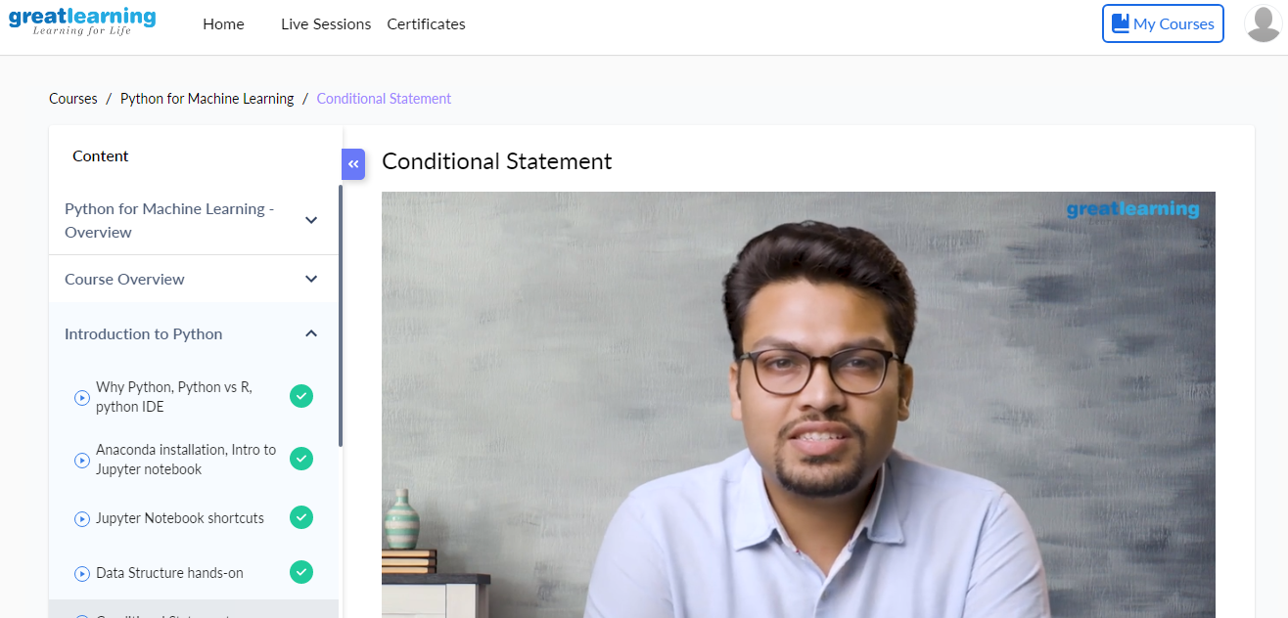

Coding Challenges Details: (Attach the snapshot and briefly write the report for the same)

Coding was given n it was uploaded for github and slack

PROGRAM1

**deffindDigitsCharsSymbols(inputString):**

**words = inputString.split()**

**charCount = 0**

**digitCount = 0**

**symbolCount = 0**

**for char in inputString:**

**if char.islower() or char.isupper():**

**charCount+=1**

**elifchar.isnumeric():**

**digitCount+=1**

**else:**

**symbolCount+=1**

**print("Chars = ", charCount, "Digits = ", digitCount, "Symbol = ", symbolCount)**

**inputString = "P@#yn2"**

**print("total counts of char**